**NetBeans IDE 6.9.1 Installation guide for the course “Level 1:Spring Framework- BTJEC6”**



**Required Software**

The Java SE Development Kit (JDK) 6.0 Update 13 or later is required to install NetBeans IDE. The 6.9.1 version of the IDE cannot be installed using JDK 5.0. You can download the latest update of JDK 6.0 at [http://java.sun.com/javase/downloads](http://java.sun.com/javase/downloads/index.jsp).

**Installer Download Options**

On the NetBeans IDE [Download page](http://netbeans.org/downloads/), you can obtain one of several installers. Choose “All” download option. This is a full download option, which contains all the runtimes and technologies available for the NetBeans IDE.

**Starting the Download**

1. Go to [**http://netbeans.org/downloads/**](http://netbeans.org/downloads/)
2. In the upper right area of the page, select the language and platform from the drop-down list. You can also choose to download and use the platform-independent zip file.
3. Click the Download button for the download option that you want to install.
4. Save the installer file to your system.

**Installing the Software**

Follow the instructions in this section to install the IDE on the system on Microsoft Windows environment.

1. After the download completes, run the installer.
2. At the Welcome page of the installation wizard, click Next.
3. At the License agreement page, review the license agreement, click the acceptance check box, and click Next.
4. At the NetBeans IDE installation page, do the following:
   1. Accept the default installation directory for the NetBeans IDE or specify another directory.

**Note:** The installation directory must be empty and the user profile you are using to run the installer must have read/write permissions for this directory

* 1. Accept the default JDK installation to use with the NetBeans IDE or select a different installation from the drop-down list. If the installation wizard did not find a compatible JDK installation to use with the NetBeans IDE, your JDK is not installed in the default location. In this case, specify the path to an installed JDK and click Next, or cancel the current installation. After installing the required JDK version you can restart the installation.

1. To install Apache Tomcat, on its installation page, accept the default installation directory or specify another installation location.
2. At the Summary page, verify that the list of components to be installed is correct and that you have adequate space on your system for the installation.
3. Click Install to begin the installation.

**Creating a Sample Spring application**

Follow the instructions in this section to create a sample Spring application

1. Start the NetBeans IDE.
2. Click File->New Project

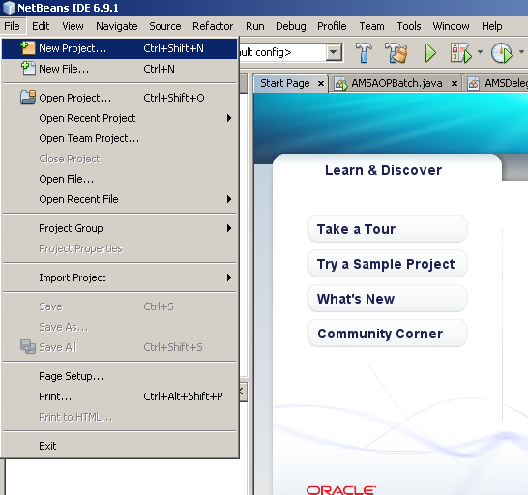

1. In the New Project section choose **Java->Java Application** and click **Next**

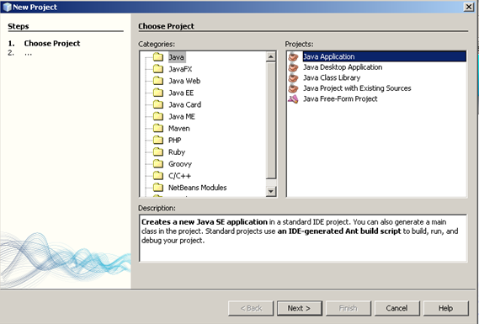

1. In the Name and Location section provide a sample application name as “**SampleApplication**”. Don’t change any other value and click **finish**

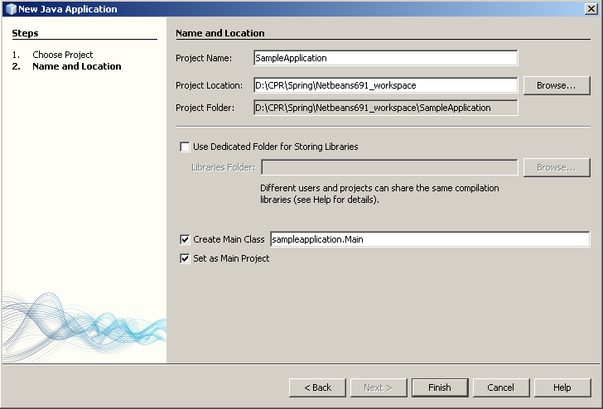

1. A Sample application is created.

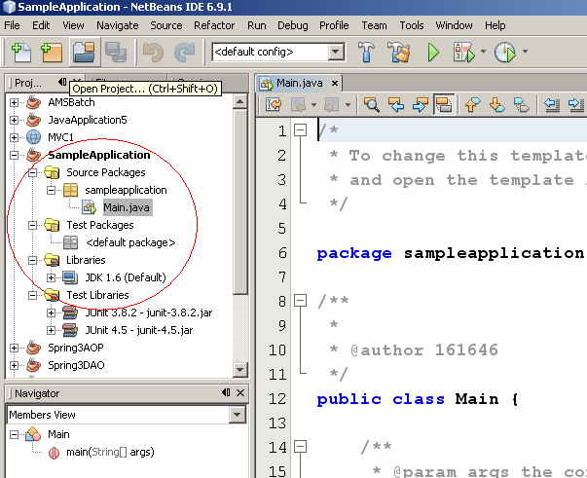

1. Right click the project and choose **properties**

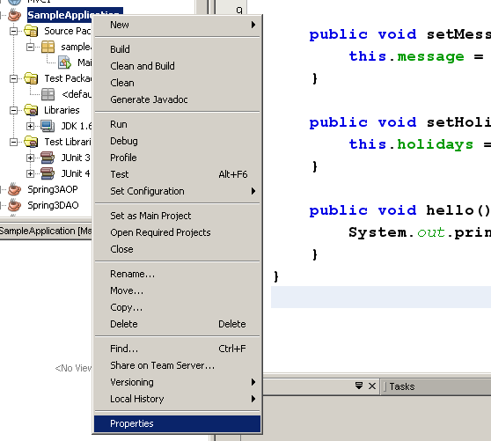

1. In the Project Properties dialog box choose **libraries** and click **Add Librar**y

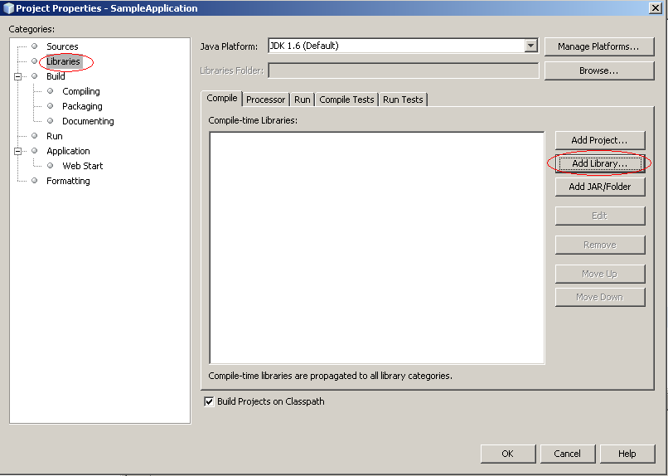

1. In the Add Library dialog box select **Spring Framework 3.0.2.RELEASE** and click **Add Librar**y and then **OK.** 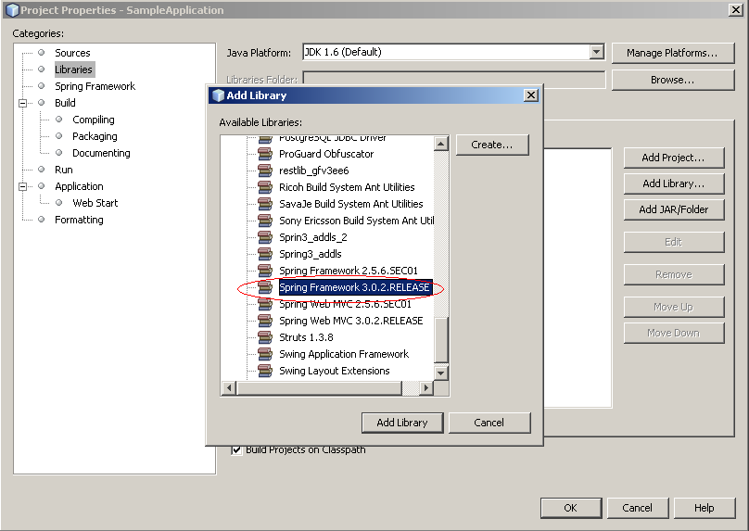
2. The Spring framework 3.0.2 jars will be added in to the project libraries.

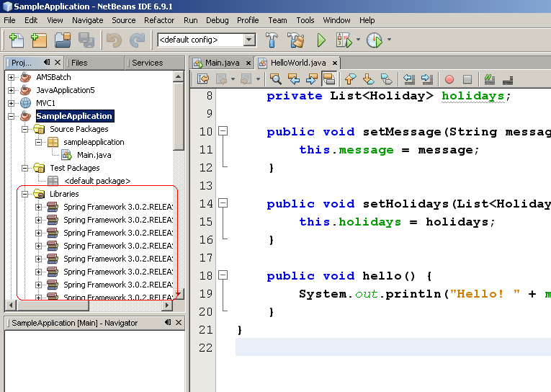

1. Create three java files in the **sampleapplication** package as follows.
   1. Right click **sampleapplicaton** package and select **New->Java Class**

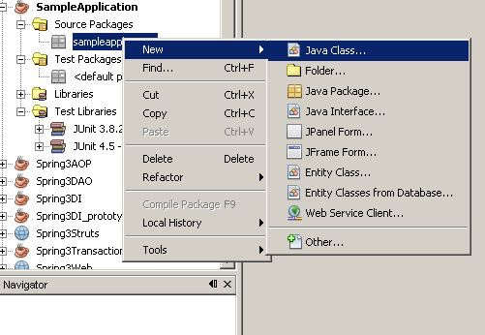

* 1. Provide the name of the class as “**HelloWorld**” and click **Finish**

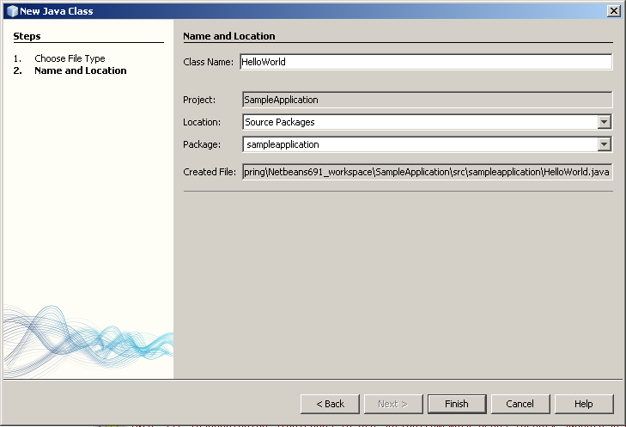

* 1. Copy the content from the file in to the created java class.
  2. Similarly create two more Java Classes Holiday and Main under sampleapplication package and replace its contents with the files respectively.

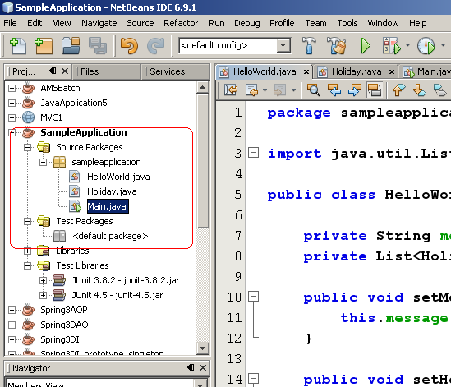

1. Create spring configuration file “beans.xml” as follows
   1. Right click the “**Source Package**” folder and click **New->Other**

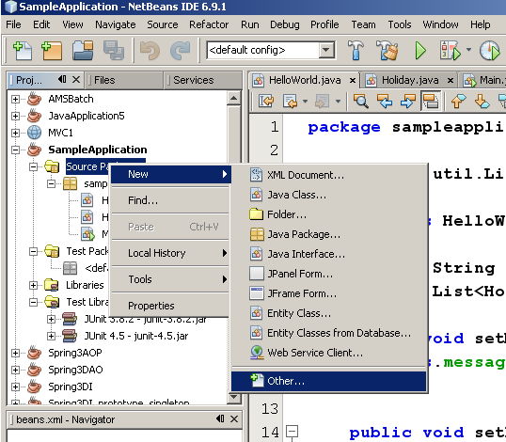

* 1. In the New File dialog box choose **XML->XML Document** and click **Next**

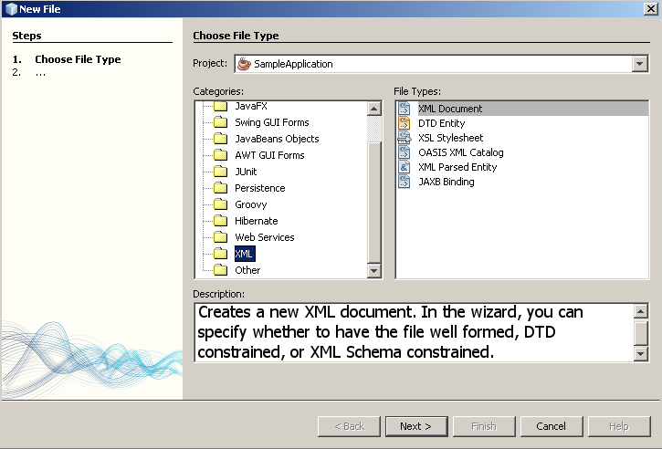

* 1. Provide the name of the xml as “**beans**” and click **Next**

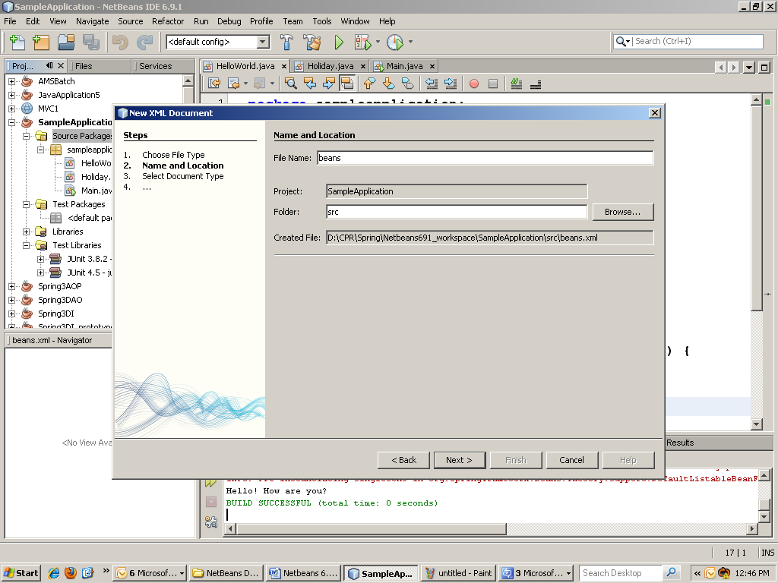

* 1. Select the document type as **well-formed Document** and click **Finish.**

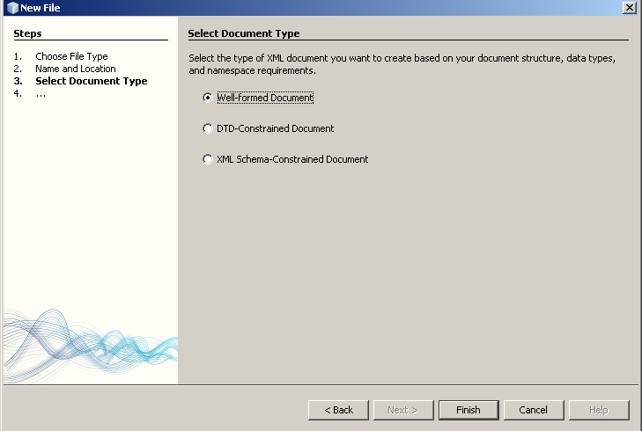

* 1. A beans.xml file is created under default package. Replace its content with the file 

1. Run Main.java by right clicking it an selecting **Run File**

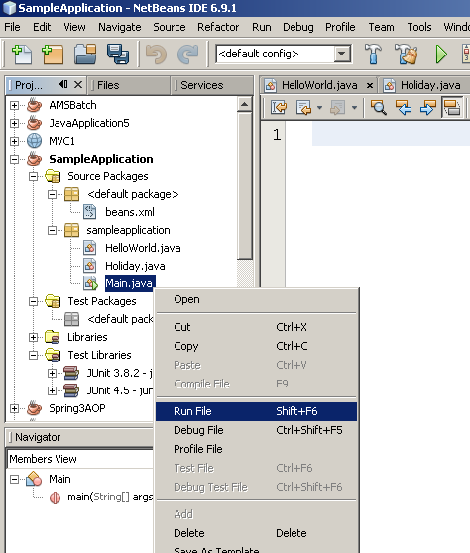

1. The result will be displayed in the Output window

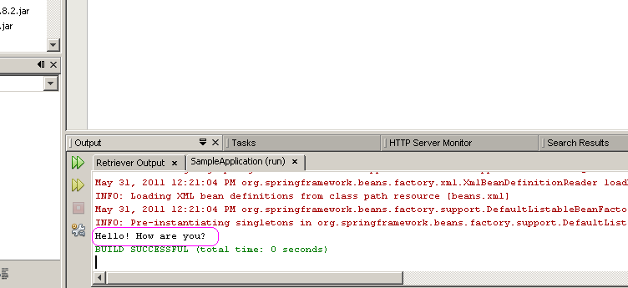

This result ensures that the NetBeans 6.9.1 installation is complete for the course “Level 1: Spring framework”

**Note to the Facilitator:** Add the individual jars in the file  in to the class path of all the demo and hands-on projects.